Table of Contents

1 | Login | 2
2 | QR codes scan | 4
3 | Weight Entry | 5
4 | Weight Submission | 6

1.Login:
1) Enter Registered Mobile Number
2) Then click on Get OTP
3) OTP will be generated and sent to registered Mobile
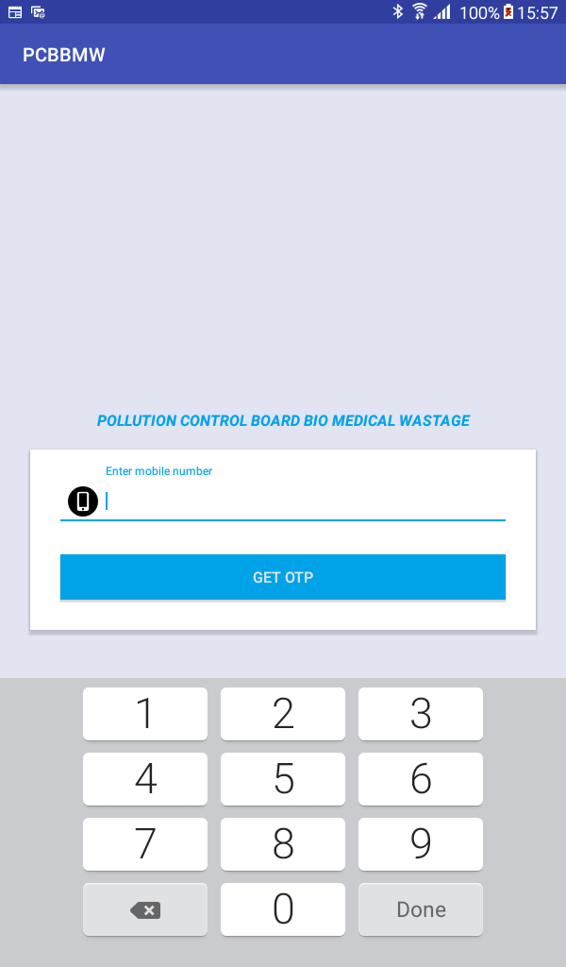

4. Enter OTP Number and click on Submit
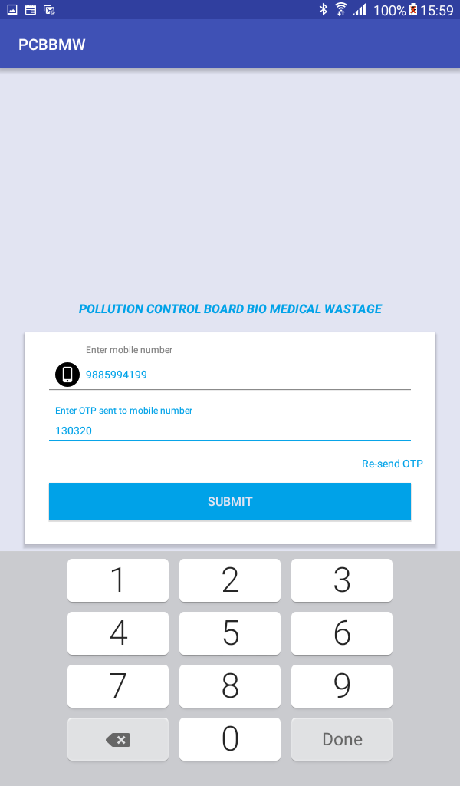

2. QR Code scan
1) After vehicle selection, click on Scan button to scan the labels

2) Point the camera on QR code
3) Weight Entry:
1) After successful scanning, weight entry popup will be appeared, enter weight and click on submit.

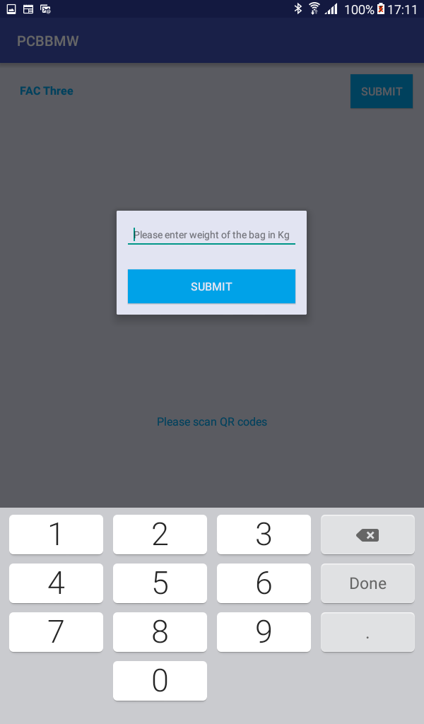

4) Weight Submission:
1) After enter weight details of bags below screen will display, Click on submit button.
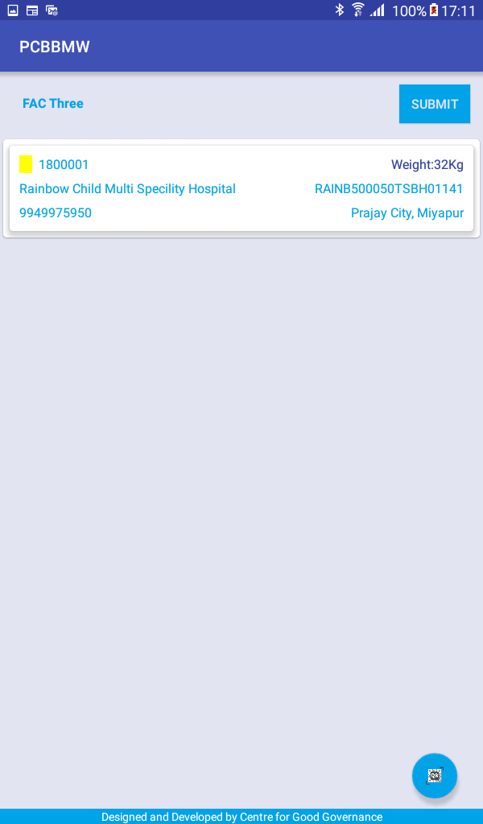

2) Then click on OK button
